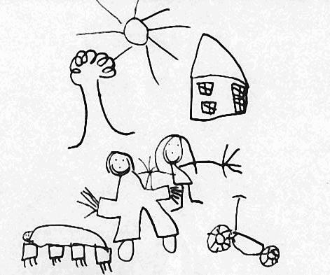
Woodend Children’s Centre
20 Bathbank Crescent.
Sheidow Park, 5158
Ph. 83221069
Fax 83228756
Email dl.3689.leaders@schools.sa.edu.au

2018 Contributions Structure
Preschool Term fees are $160.00.
This is a flat fee for the term and you are given a $10 discount if you pay in advance of the term or within the first two weeks of the term.
Parents can request options such as to pay fees for the year including /excluding excursion levy or direct debit per week or fortnight.
If you are having difficulty in paying fees are encouraged to speak with the Director confidentially.
Fees are subject to change.

